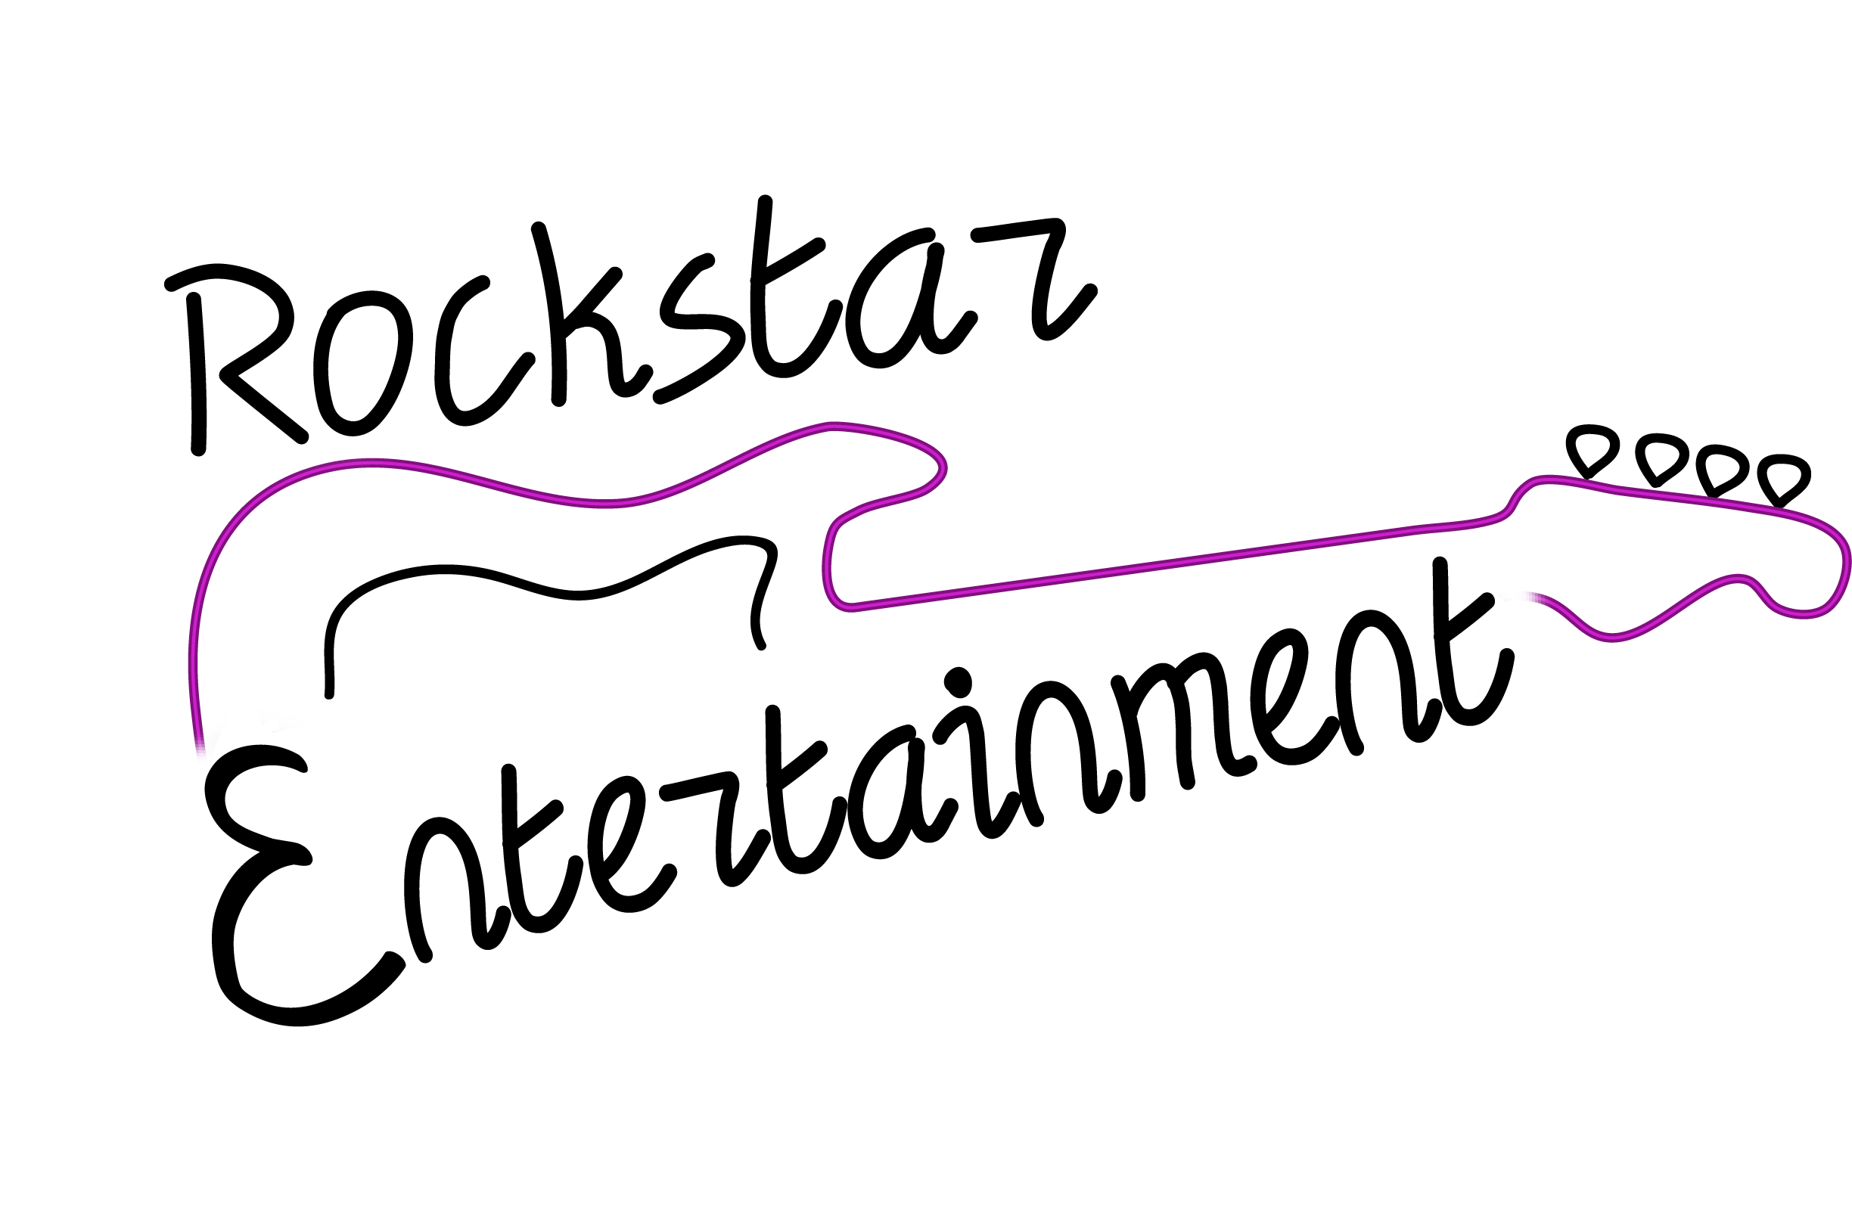
Trivia and Special Events Pricing

DJ Trivia - $150
Includes two hours of DJ Trivia and Music.
Private Parties - $100 Per Hour
Four Hours of Music
Karaoke if Wanted
Light Set-Up
$100 per hour after four hours.
Contracted Music/Karaoke - $300
Four Hours of Music
Karaoke if Wanted
Light Set-Up
$100 per hour after four hours.
School Dances - $300
Three Hours of Music
Karaoke if Wanted
Light Set-Up
$100 per hour after four hours.

MC Services - $50 P.H.
PA Rental - $125 for three hours – no set up fee
Please contact Matt at 701-367-6557
Check out Rockstar Entertainment on Facebook
www.rockstardjmhd.weebly.com

