Tammy Lynn Sanden
5.0
Most amazing dj experience
I can not say enough about Rockstar Entertainment and what an amazing job Matt did!!!! From the ceremony music to the dance it was all just perfect. He kept the kiddos entertained all night and went above and beyond our expectations. He just made our night complete! I will be recommending Matt to all I know planning a wedding.

All-Access Pass-$1200
Early Set Up Provided Lighting Wedding Officiant
Ceremony Music Cocktail Hour Music Dinner Music
Music when guests arrive
4 Hour Dance
VIP Pass-$1000
Early Set Up Provided Lighting Ceremony Music
Cocktail Hour Music Dinner Music
Music when guests arrive
4 Hour Dance
Reserved Seating Pass-$900
Early Set Up Provided Lighting Cocktail Hour Music
Dinner Music
4 Hour Dance

General Admission Pass-$800
Early Set Up Provided Lighting Dinner Music
4 Hour Dance

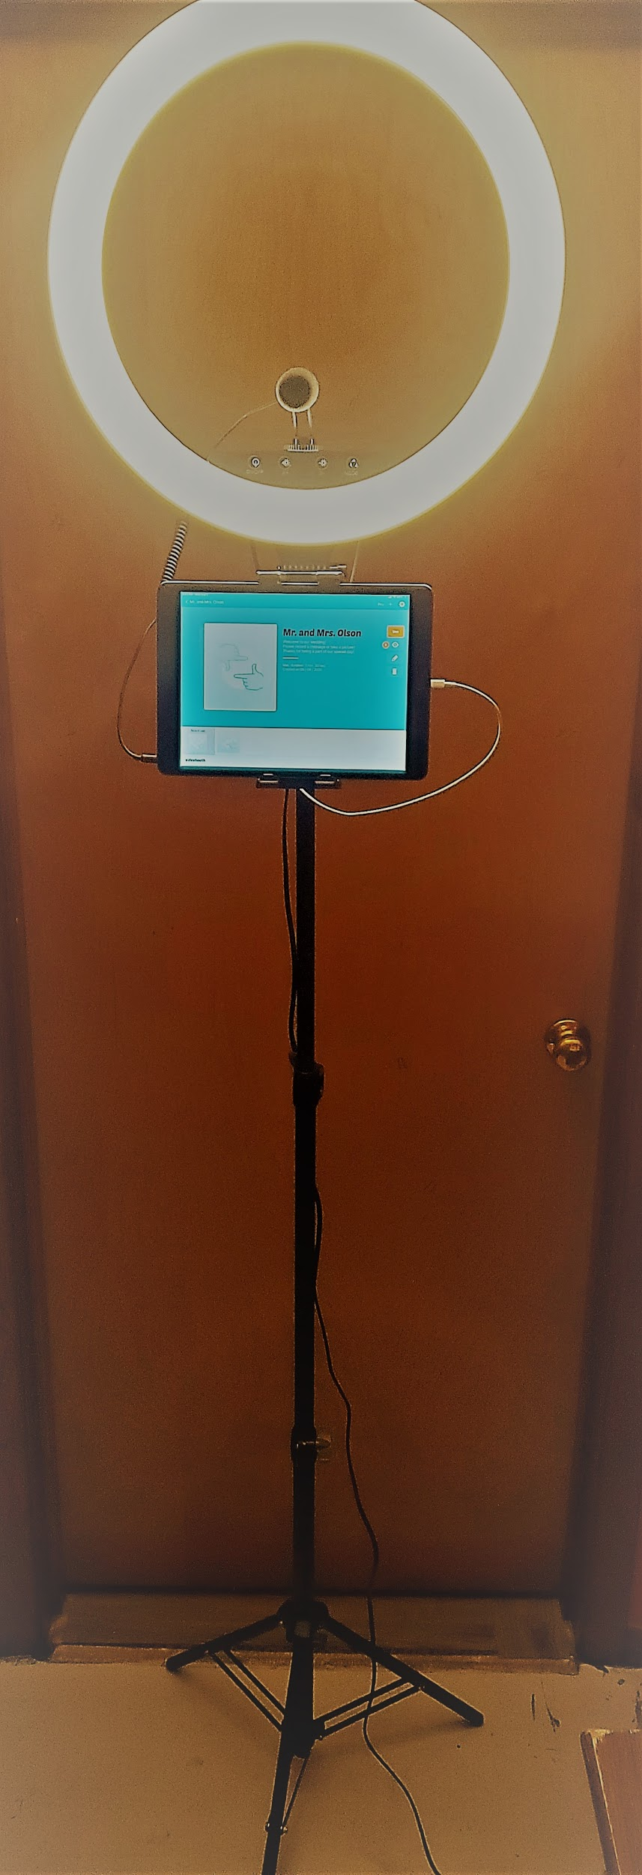
Rockstar Video Booth-$300
Customized for your wedding.

Take pictures, record videos or both.

Users also have the opportunity to add digital effects to their photos like moustaches, sombreros, etc.

Guests can email and text themselves the photos, wifi permitting.

After the event, we will send you all the digital copies from your event.

A 50% down payment is required to reserve the video booth.

“Turning Your Dreams Into Memories”

Please call Matt at 701-367-6557 or email rockstardjmhd@gmail.com to check availability and reserve your date.

